Microwave Circuit Project Report

*Chebyshev Bandpass Filter Microstrip Line*

Student name - Matrikel

Ngoc An Ha - 967813

Duy Hai Nguyen – 968045

Date

January 20th, 2014

Microwave Circuit Project Report

Chebyshev Bandpass Filter Microstrip Line

Design and implementation of bandpass filter as a microstrip coupled line circuit, using Agilents ‘Advanced Design System and optimization for desired bandwidth and Insertion loss.

|  |  |  |  |
| --- | --- | --- | --- |
| Filter type: Bandpass | | Method: Chebyshev Equal Ripple | |
| Order: N= 3 | Ripple = 0.5 dB | Center Frequency  F0 = 2.45 GHz | Bandwidth  B=100 MHz |

|  |  |  |  |  |
| --- | --- | --- | --- | --- |
| N | G1 | G2 | G3 | G4 |
| 3 | 1.596 | 1.097 | 1.596 | 1 |

We divide the whole project into the following steps:

Step 1: Create lump element low pass prototype filter. Then transform to lump element bandpass filter circuit.

Step 2: Transformation to a filter structure realizable in microstrip line circuit

1. Using ideal couple transmission line element (CLIN) in circuit.
2. Using microstrip couple line (MCLIN) element.
3. Using microstrip couple line filter (MCFIL) element.

Optimized the circuit to compensate the different between the ideal and real microstrip couple line.

Step 3: Include all microstrip line discontinuities. Using both S-Simulation and EM Simulation in order to find the different in behavior of the circuit when running under the real condition.

Step 4: Optimize the circuit to get the EM simulation result close to S-Simulation in the above step as much as possible.

Step 5: Process on making the real circuit. Using Network Analyzer to test the circuit and get the measurement result. Compare with the simulate result from EM Simulation in ADS.

# Making Lumped Element Bandpass prototype filter.

## 1. Lumped element low pass filter

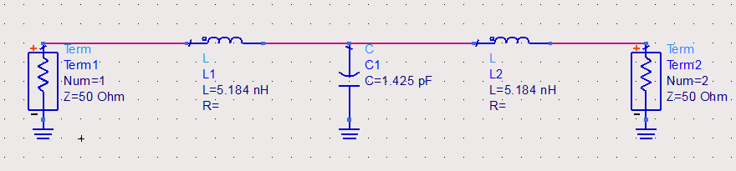

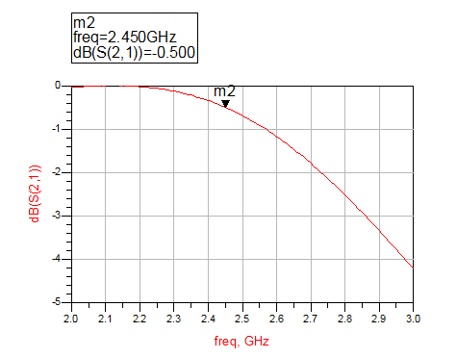

Figure 1: Lump element low pass filter circuit schematic and simulation result

Using the given frequency 2.45 GHz and Zc = 50 Ohm, we calculated the statistic data and use it for the prototype lumped element low pass filter.

The simulation shows that with this low pass filter, at the given frequency, the reflection efficient has the value of –0.5 dB. This result is good, it shows that our calculation was right.

## 2. Lumped Element Bandpass Filter

## 

## 

Figure 2 : Lump element bandpass filter schematic and simulation result

## In this step, we construct a distribute element bandpass filter circuit, using Richard’s Transformation. The simulation shows that we had succeed create a bandpass filter with ripple.

## Up until this step, we only make the circuit base on the theory. From here, we cannot use Kuroda Identities to advance further. Due to the fact that the Kuroda requires an ideal transformer component, which is inappropriate for our circuit. Moreover, in reality, the Kuroda and Richard Transformation are more suitable for the low pass filter. We would like to design the bandpass filter with another method: microstrip couple line.

# Transformation to a filter structure realizable in microstrip line circuit technique

## Using the Ideal Couple Line element CLIN in circuit

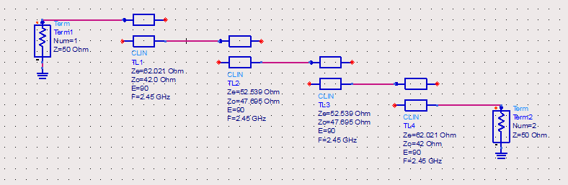

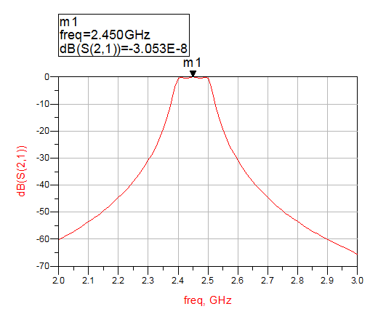

Figure 3: CLIN bandpass filter schematic and result

Here, we construct the bandpass couple line circuit using Ideal Couple Transmission Line CLIN. The result is almost the same as when we construct the ideal lumped element bandpass filter.

Using the center frequency, bandwidth, we calculated the even and odd mode impedance of the coupled line.

∆=B/F0=100 MHz /2450 MHz = 0.0408

|  |  |  |  |
| --- | --- | --- | --- |
| ∂1 = $\sqrt{\frac{πΔ}{2g1}}$ | ∂2 = $\frac{πΔ}{2\sqrt{g1g2}}$ | ∂3 = $\frac{πΔ}{2\sqrt{g2g3}}$ | ∂4 = $\sqrt{\frac{πΔ}{2g3g4}}$ |
| ∂1=0.2003 | ∂2=0.04844 | ∂3=0.04844 | ∂4=0.2003 |
| Zcen = Z0 (1+∂n + ∂n­2) = 50 Ω * (1+∂n + ∂n­2) | | | |
| Zce1 = 62.021Ω | Zce2 = 52.539 Ω | Zce3=52.539 Ω | Zce4=62.021 Ω |
| Zcon = Z0 (1-∂n + ∂n­2) = 50 Ω * (1-∂n + ∂n­2) | | | |
| Zco1=42 Ω | Zco2=47.695 Ω | Zco3=47.695 Ω | Zco4=42 Ω |

## Transforming to Microstrip Couple Line element MCLIN circuit

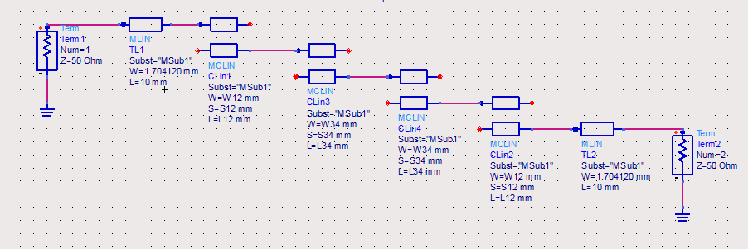

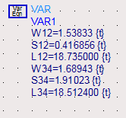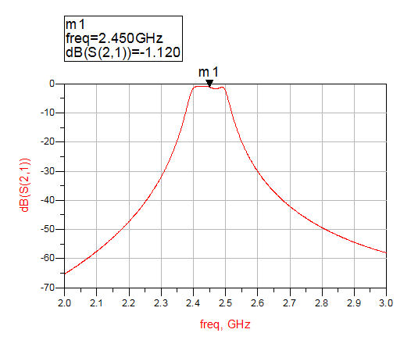

Figure 4: MCLIN circuit schematic, variables value and simulation result

In above section it is just the ideal couple line. We would like to realize it by using microstrip couple line elements. Therefore, we replaced CLIN by MCLIN.

Using the tool LineCal of ADS, with the Effective Electrical Length E_Eff of coupled section at 90 degree and center frequency at 2.45 GHz, we obtain the variable data for the Microstrip Couple Line. The reason we choose the E_Eff at 90 degree because from the design of the couple line method bandpass, each couple line must have $\frac{λ}{4}$ electrical length.

As the figure shows that we had fewer ripple and the loss has increased. The loss happen due to the realization of the physical microstrip. (i.e.: substrate material)

We additionally added two transmission line at both terminals. Their widths W(s) are 1.704 mm, it is equivalent to 50 Ohm transmission line. Their lengths L does not affect the behavior of the circuit, so we can apply any value. Here, we choose 10mm.

# Transforming to Microstrip Couple Line Filter element MCFIL circuit

## 

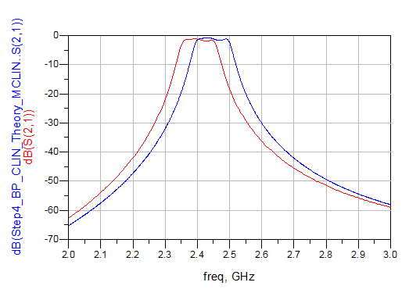***Before Optimization***



Figure 5: Reflection coefficient S(2,1) comparison between using MCLIN and MCFIL before optimization

Here, we apply the Microstrip Couple Line Filter element MCFIL in our circuit. The reason is because ADS will treat MCLIN as an infinite length, which is completely different from what we need.

Using MCFIL let us have a more realistic behavior of our circuit, where the couple line is openly terminated. Moreover, it also allows ADS count in the case where the Electrical Field create a capacitor run in the air from the couple line, which lead to the fringing effect inside the circuit. Due to the fringing effect, our center frequency shifted a little bit – around 0.05 GHz to the left. So, we had to optimize it.

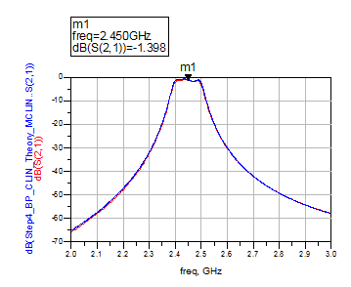

***After Optimization***

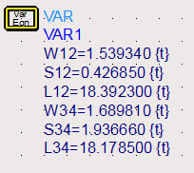

Figure 6: Reflection coefficient S(2,1) comparison between using MCLIN and MCFIL after optimization

After the process of optimization, we got a new variable data and the result is acceptable. In details, we would create a completely new circuit with a different center frequency which in real time should behave like the initial filter.

In this case, due to the fact that the fringing effect only reduce the center frequency without changing the shape of the behavior, we easily optimized by increase the initial center frequency by 0.05 GHz and redo the calculation. In theory, this is the bandpass filter with center frequency is 2.5 GHz. As expected, the new circuit have the same real life behavior as the ideal initial filter.

Add all microstrip line discontinuities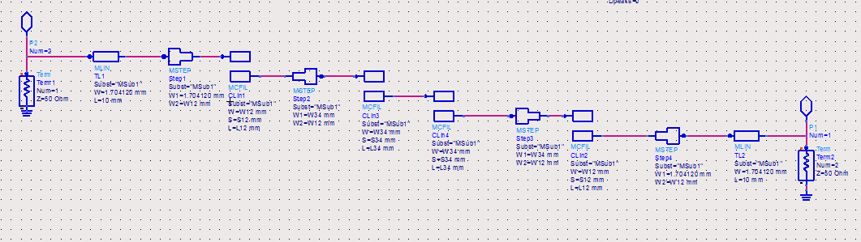

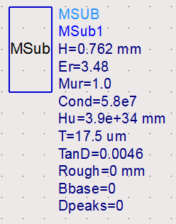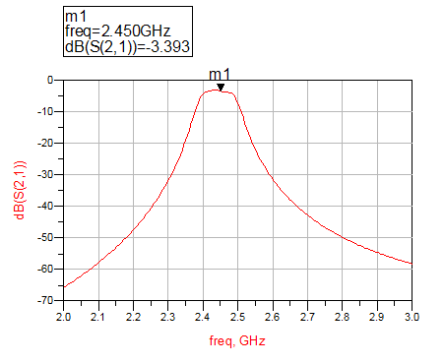

Figure 7: Discontinuities included circuit schematic, variables and simulation result

Here we use the MSTEP components to have a better simulation, where the differences in width between 2 part of a microstrip line are counted in. This different in dimension is considered as the discontinuities.

After that, by using layout generation function of ADS, we are able to get the layout of the filter circuit. Then, we can use ADS EM simulation function which include the electrical magnetic affections to get the result that the circuit may possibly behave in reality.

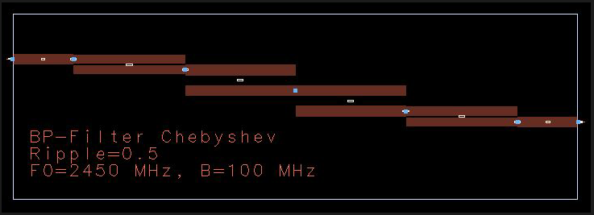

Figure 8 : Circuit layout generated by ADS.

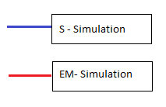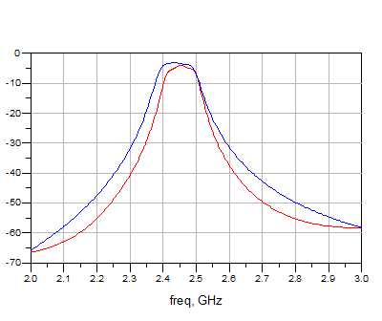

Figure 9: Comparison between momentum and schematic simulation

Compare to the S-Simulation, because of the intervention of the substrate, the momentum simulation result show that its bandwidth will decrease, the center frequency will be shifted, and the power loss increased. Moreover, the ripple also changed. In other word, the circuit will behave completely different from what we want. As it is now, we need to optimize the circuit, by changing the variable values, so that we can achieve a better result. There is no choice but to change it manually and keep testing the result.

# Optimize the circuit to get the best EM simulation result

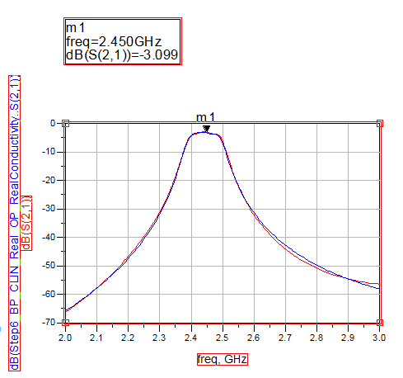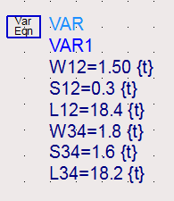

Figure 10: Comparison between the behavior of the S-Simulation and EM-Simulation after optimization

Now we have a completely new filter circuit with different data in theory, but in reality, it will behave like the initial condition of our project bandpass filter: Center frequency 2.45 GHz, bandwidth 100 MHz.

Here, the variables was rounded up in order to make it easier to make the circuit based on the dimension of the drill.

# Using Network Analyzer to test the circuit and get the measurement result.

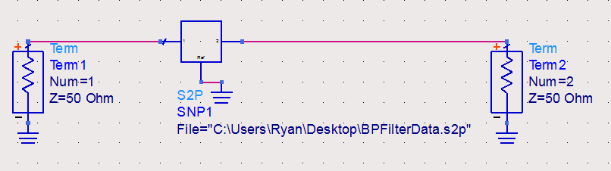

After making the circuit board, we continue on testing the circuit by using a Network Analyzer to analyze the circuit. After that, we export the value data from the network analyzer to compare with the theory simulation result.

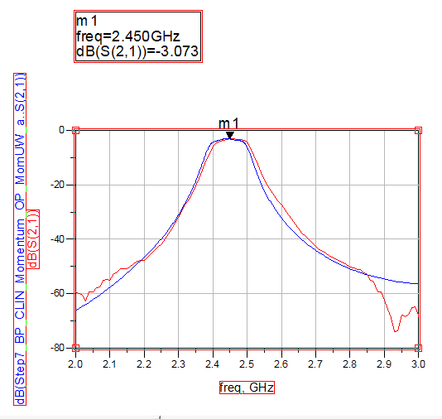

Figure 11: Comparison result between the reality and the theory value

# Conclusion

The bandwidth is similar between the real and the simulation so it means we did successful in realization. However, error occurred (center frequency shifted- this might be explained due to the substrate material and the circuit making process, the damping we cannot avoid regarding to the material.)